**Cure Deliverable 3**

**Due: October 30, 2023**

**Made By:**

Group 103

**Editors:**

Opeyemi Sanyaolu (30156143)

Mendjemo Ngangom Gerard Ledoux (30192835)

Kosy Onyejemezi (30189156)

Chidera Awiaka (30165302)

**Task 1**

|  |  |  |  |  |
| --- | --- | --- | --- | --- |
| **Member** | **Topic** | **# of Classes** | **# of Numeric Attributes** | **# of Instances** |
| Opeyemi Sanyaolu | Classification of Vehicle Data | 2 | 2 | 5 |
| Kosy Onyejemezi | Classification of houses | 2 | 3 | 12 |
| Mendjemo Gerard | Classification of animals | 2 | 2 | 10 |
| Chidera  Awiaka | Classification of Stationary Sales | 2 | 3 | 14 |

We chose to expand on the classification of vehicle dataset. The dataset has been initialized with 100 instances instead of 5.

**Task 2**

1. Classification of Vehicle Data.
2. The Classification of vehicle data describes different attributes customers may want to consider when purchasing a new vehicle, allowing customers to easily compare the make, price, horsepower, and top speed.

Description of data:

* Number of instances: 100 (at least 30 per class)
* Number of attributes: 3 numeric attributes (Price, horsepower, top speed)
* Number of classes: 2 (Overseas, American)
* Creator: Opeyemi Sanyaolu

1. Dataset:

Classification of Vehicle Data

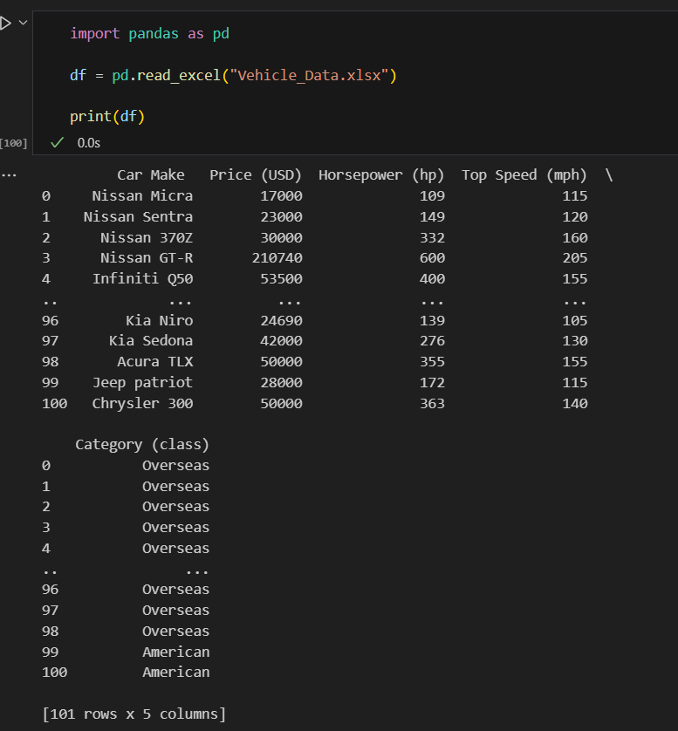

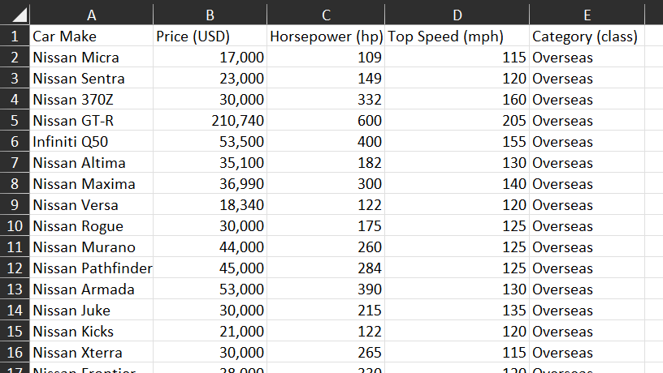

Sources for the table above can be found in the reference section at the very bottom.

**Task 3**

**a) b) c)**

**Code**

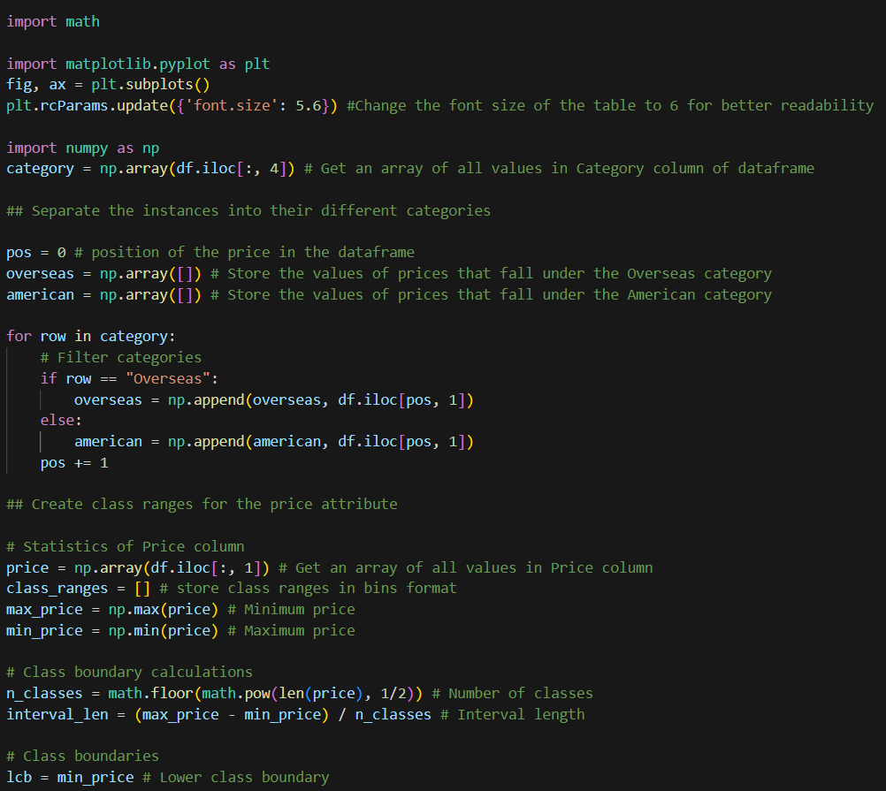

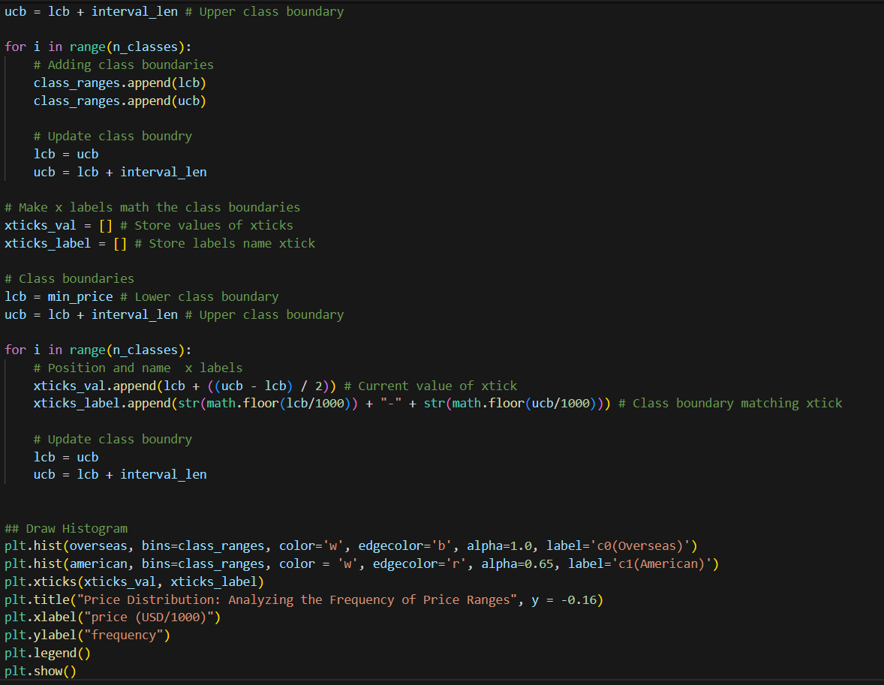

**Graph**

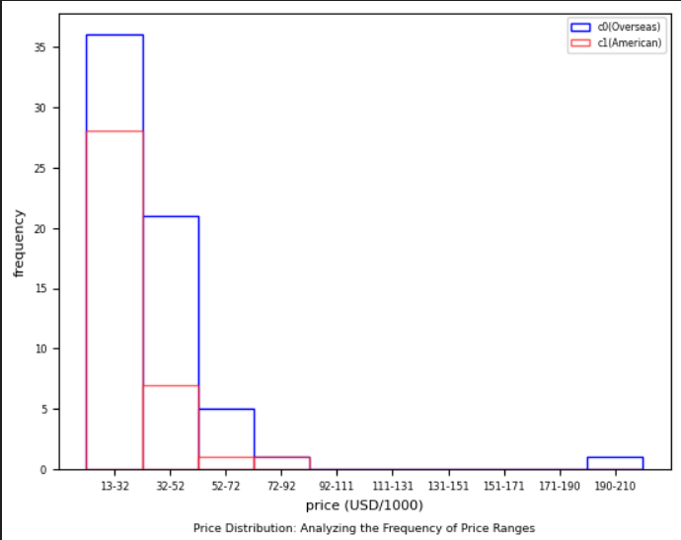

**Code**

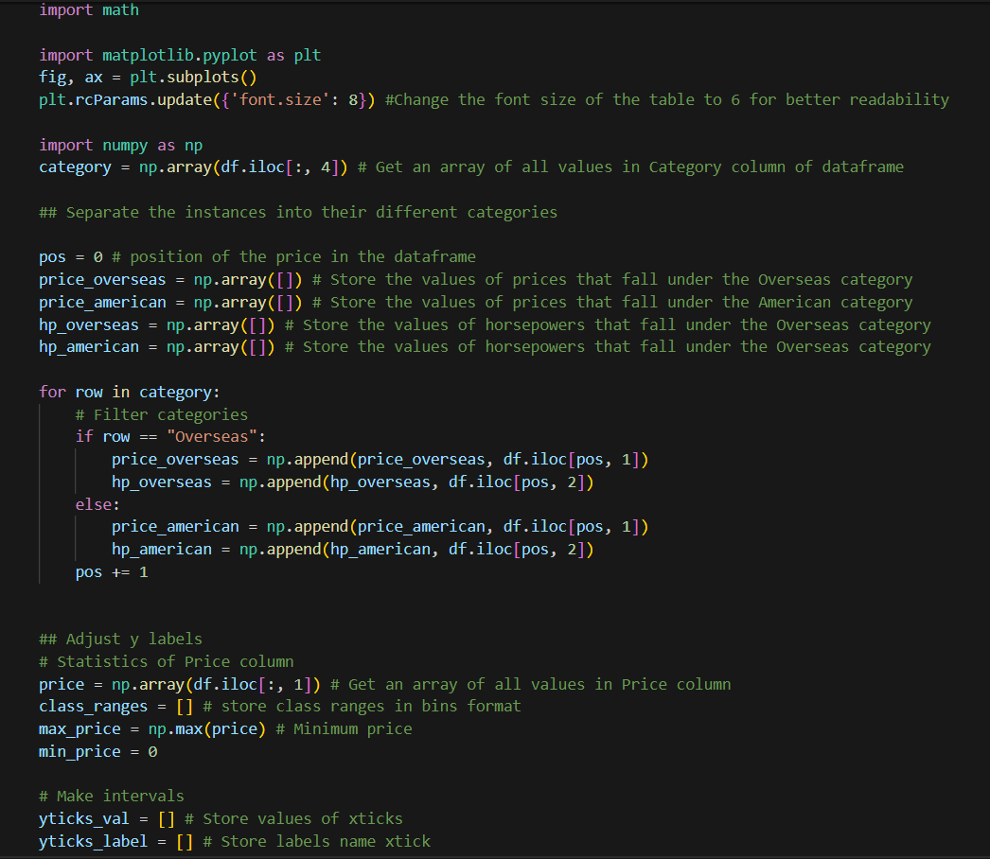

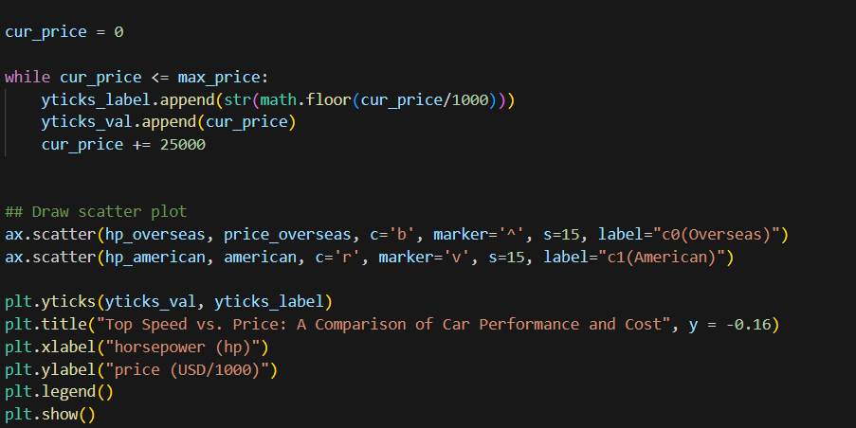

**Graph**

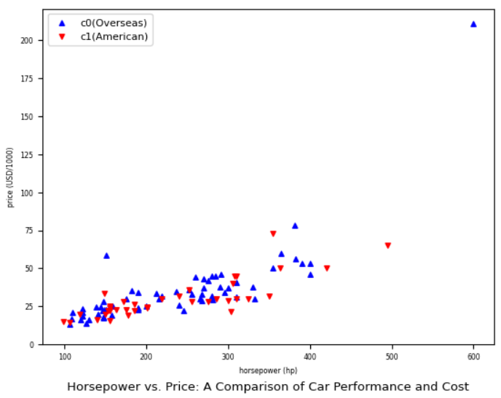

**Description:** The graph above reveals the relationship between the horsepower and the price in the cars made in America (red), vs the ones made overseas (blue). The scatter plot shows that a car with a higher horsepower would usually be more expensive than one with a lower horsepower, with the cars made overseas being a bit more expensive. However, there are some exceptions as other factors could also affect the price of the car.

**Code**

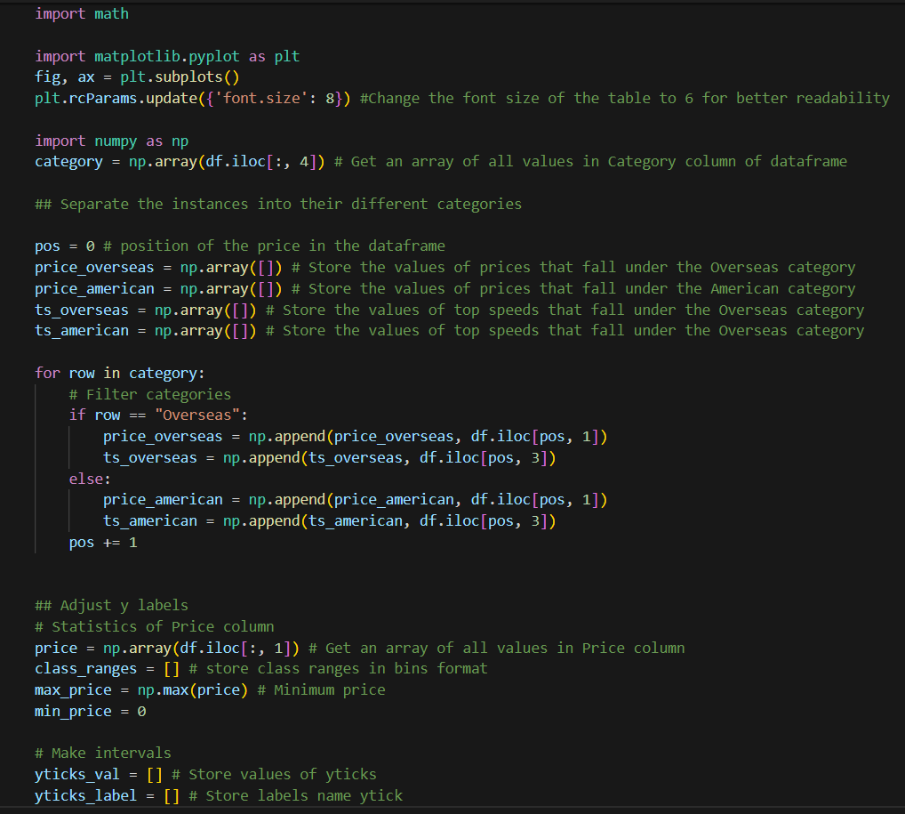

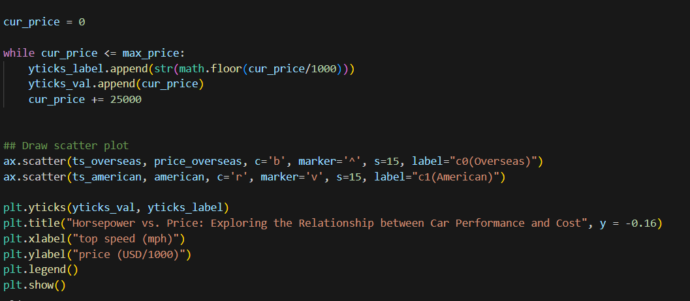

**Graph**

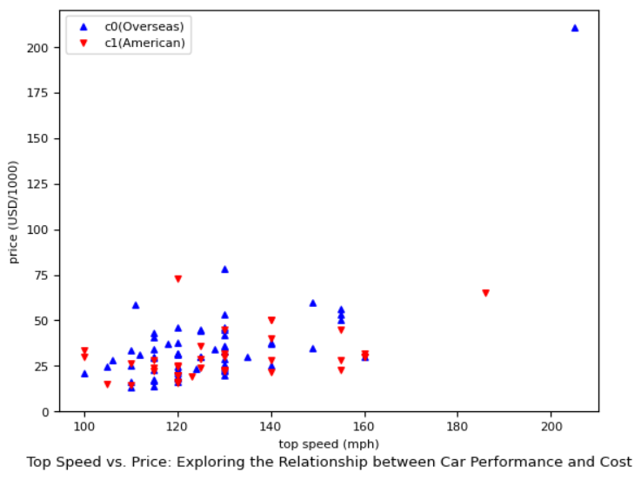

**Description**: The graph above reveals the relationship between the top speed and the price in the cars made in America (red), vs the ones made overseas (blue). The scatter plot shows that the top speed of a car does not typically affect the price of a car the same way its horsepower does as there are many instances where cars with the same top speed have a wide range of prices. Furthermore, the cars made overseas were more expensive in comparison to the American made ones in terms of top speed.

d) We believe a machine learning model should easily be able to classify a new instance within our dataset. As it should be easy to tell whether the car was made overseas or in America from the make of the car, as well as find out where the top speed, horsepower, and price should fit in.

**References**

[**https://www.autoevolution.com/cars/**](https://www.autoevolution.com/cars/)

[**https://fastestlaps.com/makes**](https://fastestlaps.com/makes)

[**https://www.edmunds.com/sedan/#x-small-sedans**](https://www.edmunds.com/sedan/#x-small-sedans)

[**https://driving.ca/nissan/altima/**](https://driving.ca/nissan/altima/)